**Object-oriented example:**

**House**

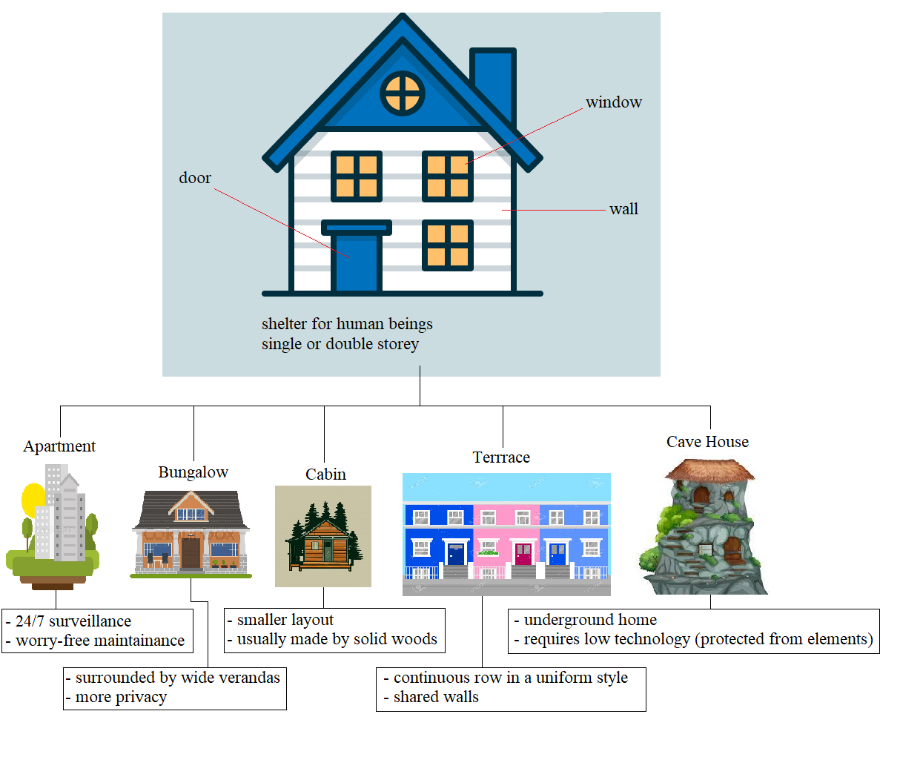

Ginveree 279045